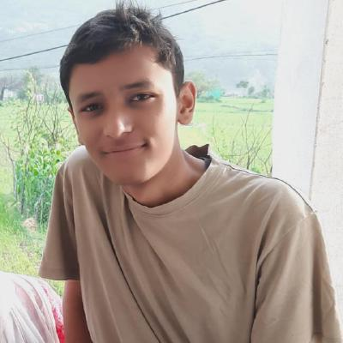

Node

**C**

**JS**

Java

Java

ABHISHEK

**BHATT**

FRONT-END DEVELOPER | GRAPHIC DESIGNER | STUDENT | CONTRIBUTER

Pursing B.tech in Computer science and engineering from Graphic Era university.  
1st semester is over and secured 9.48 CGPA in it.

Contributed to a Github repo. The repo was for online teaching where java codes contribution was made by me.

Simon – A memory based game developed in pure javascript.

Check it out over here:  
https://abhishekbhatt072003.github.io/Simon-game/

Internship at BigFoot Learning, where our job was to deliver day to day tasks provided to us.

**Github Contribution**

**Internship – BigFoot Learning**

Frontend-Developer

**Simon Game**

**B.tech CSE** (2020-2024)

Graphic Era University, Dehradun, Uttrakhand, India

**High School and Intermediate** (2018-2020)

St. Theresa’s convent School, Srinagar, Uttrakhand India

https://abhishekbhatt072003.github.io/Portfolio/

abhishekbhatt072003@gmail.com

**MY SKILLS**

**Projects and Work**

I want to become a front-end developer and a open source contributer. I’m most comfortable in that weird funky world between design and development- that’s where the most fun, creative, boundary-breaking works happens.

**ABOUT ME**

**HOBBIES**

**EDUCATION**

Reading

Node.js

JavaScript

C language

Completed my 10th and 12th from St. Theresa’s Convent School with 85% and 90% grades respectively.

Basketball

Music

Hiking

Korean

Hindi

English

**LANGUAGES**

9027375224